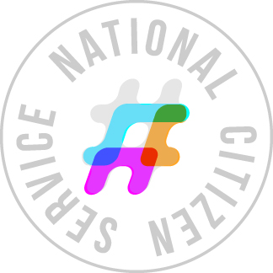
Bursary Application Form

Name:
Date of Birth:
Address:
School:

If family circumstances make paying the participation fee difficult please explain below:

If you are able to make a small contribution towards your son/daughter’s participation of the programme, then please write amount in box below:
£

Declaration: I hereby apply for an NCS bursary. I understand that applying for a bursary is not the same as registering for the NCS Programme or confirming an NCS wave. I confirm my entitlement under the criteria listed above. I understand that each bursary is valid for one NCS participation fee only. I understand that if I breach or ignore these conditions I will not be entitled to another bursary to cover the cost of another NCS fee.

Parent/Guardian’s Name:
Parent/Guardian’s Signature:
Date:

Teacher Declaration: I believe the above information to be correct to the best of my knowledge. I believe the bursary applicant has the intention to complete the NCS Programme.

Teacher’s Name
Teacher’s Signature:
Date:

