STEPS
TARGETED FRAMEWORK FOR SCHOOLS
This framework is designed to be used as a tool to:
- Complement the Universal Scheme of Learning that is delivered across settings.
- Support schools and education groups with small groups and provide a space to discuss issues related to misogynistic behaviours and language.
- Provide additional support and time to discuss issues around Respectful Relationships in line with RSHE guidance.
The Framework has been developed to be taught to boys in Years 5 and 6 (KS2); Years 7 and 8 (KS3). It complements the Universal Scheme of Learning aimed at these specific age ranges.
The framework provides guidance for work with small groups over a six week period, this works when part of a ‘whole school approach’ including:
- Delivery of the Universal Scheme of Learning;
- Having clear policies in place;
- Promoting training and open discussion around wider issues that impact children and young people;
- Part of a long-term sustainable programme that returns to the themes within this scheme of learning and is responsive to contextual and local and national trends and patterns.

This Framework for targeted support was developed by Talk Listen Change over a twelve month period which included the piloting of the material across Greater Manchester. Talk Listen Change worked alongside Salford Foundation as part of a commission by Greater Manchester VRU. The final content was determined through adaptations that were made over the course of the 12 months through working directly with small groups across the GM region in primary and secondary.
The intervention has undergone substantive quality assurance both within Talk Listen Change and alongside Salford Foundation practitioners.
What is presented gives an outline of how the intervention can work and guidance for the facilitator in how to address specific language and beliefs that may present itself. It will not cover all aspects that are presented, but by providing the space to explore this alongside specific guidance for facilitators, it opens up a conversation which is the beginning of the journey in addressing Violence Against Women and Girls.

SCOPE OF THE CONTENT
The content covers five areas:
- Healthy and unhealthy relationships
- Hyper masculinity
- Online misogyny
- Positive bystander actions
- Positive aspects of male culture
The material is devised so that it provides a framework around key areas that come up in discussion during universal sessions and where teachers may feel that there is a need for discussion in greater depth. It has been developed to work with small groups and, as such, there is flexibility within the material for the facilitator to be able to respond within the sessions. It is anticipated that pupils will bring to these sessions some knowledge and questions from the universal sessions. Throughout the sessions there is support for pupils to be able to recognise emotions and develop a vocabulary that enables them to talk about them. They also provide strategies for pupils to regulate and develop responsible decision making skills.
These targeted sessions are not designed to be an intensive one to one intervention or to address harmful sexual behaviours and we recommend that school leaders access external specialist support when working with young people for whom there is a serious safeguarding concern. Where there is an indication that a young person is at risk of committing a violent act or expresses admiration for those who commit violent acts against women and girls that this is escalated within school Safeguarding procedures and consideration is given to their further involvement in this group.

Session One
The first session encourages pupils to think about what constitutes healthy and unhealthy behaviours in a relationship. This could be in a platonic relationship and also in a romantic relationship. The session develops thinking around this to explore how unhealthy behaviours may manifest themselves slowly. It encourages the pupils to talk through a number of different scenarios and think about how they may act as a positive bystander. Finally, it focuses on the concept of respect for their self and respect for others and what this looks like.
Session Two
The second session uses word associations that pupils will be familiar with from the universal sessions and extends this into how sometimes this language means that they over-regulate and suppress their emotions and/or behaviours. It explores the concept of hyper-masculinity and how this can be promoted online in both positive and negative ways. The session ends with the group encouraged to think about healthy masculine behaviour.
Session Three
This session delves into the impact of online misogyny. It explores a number of different comments that are made online and how these reinforce stereotypes and behaviours towards women that dehumanise and can cause mental harm and contribute to physical harm. It explores how humour is often used to deflect away from harm and the negative impact of what is being communicated. The session pre-empts the following session that links into being a positive bystander.
There is a follow up session that facilitators may choose to utilise that looks at the impact of online pornography. Whilst this is aimed at Secondary school age pupils, there may be instances where elements may be needed to addressed with upper Key Stage 2. The Children’s Commissioner’s series of reports into online pornography highlights the exposure of this on children as young as 9. If the decision is made to explore this, we recommend that it is one that is undertaken in conjunction with the Leadership Team within schools. There are no images shared in these sessions; what it does is look at how unhealthy stereotypes of men and women are portrayed in online pornography and the impact of this in healthy and unhealthy relationships.
Session Four
The focus of this session is around positive bystander behaviour with a deeper exploration of scenarios that children may find themselves in. It gives them strategies to be able to address unhealthy behaviours and to recognise when it is safe to do so.
Session Five
The final session focuses on developing a positive male culture and what is in the gift of children to control and influence. It explores how we can work together in order to develop a sense of belonging so that we can thrive and flourish in school and within our wider social and online communities. The session also provides practical strategies for pupils in regulating their emotions.

LINKS TO DEPARTMENT FOR EDUCATION GUIDANCE ON RELATIONSHIPS, SEX AND HEALTH EDUCATION
The DfE outlines that each primary school should have a policy that defines Relationships Education and each secondary school should have a policy that defines Relationships and Sex Education. This programme should therefore be looked at in light of each school’s policy in this area to ensure it complements work already undertaken in the taught curriculum.
The material contained within this programme aims to ensure compliance with the requirement to fulfil the Equality Duty in the DfE Policy on positive action, namely paragraphs 29-32 and to ensure that it is tailored for specific needs of pupils at different developmental stages and particularly for those with SEND in preparing for adulthood outcomes as set out in the SEND code of practice (paragraphs 33-35). To achieve this, it has gone through significant quality assurance that has been developed further with our pilot schools.
For Primary Schools, the material covers:
- Caring friendships: in particular the characteristics of friendships; that healthy friendships are positive and welcoming towards others, and do not make others feel lonely or excluded; how to recognise who to trust and who not to trust, how to judge when a friendship is making them feel unhappy or uncomfortable, managing conflict, how to manage these situations and how to seek advice from others, if needed.
- Respectful relationships: the importance of respecting others; practical steps they can take in a range of different contexts to improve or support respectful relationships; the importance of self-respect and how this links to their own happiness; different types of bullying, the impact of bullying, responsibilities of bystanders (primarily reporting bullying to an adult); what a stereotype is, and how stereotypes can be unfair, negative or destructive; the importance of permission-seeking and giving in relationships with friends, peers and adults.
- Online relationships: including that the same principles apply to online relationships as face-to-face relationships; how to recognise risks, harmful content and contact, and how to report them; how to critically consider their online friendships and sources of information; how information and data is shared and used online.
- Being safe: what sort of boundaries are appropriate in friendships (including in a digital context); that each person’s body belong to them, and the differences between appropriate and inappropriate or unsafe physical, and other, contact (including online); how to report concerns or abuse, and the vocabulary and confidence needed to do so.

The material reinforces the importance of positive relationships and to identify how less positive relationships do not support their emotional and mental wellbeing. It does not teach specifically about consent but focuses on the importance of boundaries and how to manage this including online. The material does not cover sex education.
For Secondary Schools, the material covers:
- Respectful relationships: the characteristics of positive and healthy friendships including in particular boundaries, privacy and consent; practical steps they can take in a range of different contexts to improve or support respectful relationships; how stereotypes can cause damage including how they might normalise non-consensual behaviour or encourage prejudice; that some types of behaviour within relationships are criminal, including violent behaviour and coercive control; what constitutes sexual harassment and sexual violence and why these are always unacceptable.
- Online and media: their rights, responsibilities and opportunities online, including the same expectations of behaviour apply in all contexts, including online; online risks, including that any material someone provides to another has the potential to be shared online; not to provide material to others that they would not want shared further and not to share personal material which is sent to them; the impact of viewing harmful content; how information and data is generated, collected, shared and used online. There is an additional session that addresses how specifically sexually explicit material e.g. pornography presents a distorted picture of sexual behaviours and how this can damage the way people see themselves in relation to others and negatively affect how they behave towards sexual partners.
- Being safe: the concepts of, and laws relating to sexual consent, sexual exploitation and abuse.
Throughout the material, there is a focus on self-respect and positive ways to support mental health and wellbeing of pupils.
The PSHE Association guides teachers in developing a curriculum that can either be built chronologically or around competencies. They identify the competencies as: Independence and Aspirations; Choices and Influences; Autonomy and Advocacy. This scheme of learning fits into the competencies of Choices and Influences and Autonomy and Advocacy.

In developing this targeted programme, we ensured that it complemented the Universal Offer but allowed facilitators to explore some issues in greater depth with smaller groups of children. It has been refined after piloting and receiving feedback in a number of primary and secondary schools.
We recognise that the use of AI may come up within these sessions. Our appendices highlight where facilitators can go or additional advice. It is not specifically addressed in these sessions until we have wider literature and research in relation to this area and we look towards developing further guidance around this area.
This guide provides a framework for facilitators to use and we have taken our experiences in forming this. It differs from the Universal framework in its structure because it omits pupil activities. This is because the nature of it is discursive. Where pupils are expected to create or deliver independently this is highlighted. It cannot cover everything, nor account for context and wider factors that may impact the make-up of the group. Our aim is to provide a starting point and for facilitators to recognise this is part of the education journey, not an end point.
The experience that is drawn on to create this framework is underpinned by the theoretical practice of Talk, Listen, Change who work with groups of young people and also deliver one to one sessions with perpetrators of Domestic Abuse.

Session One
Learning objectives:
- To understand, and be able to distinguish, the difference between healthy and unhealthy behaviours in a relationship.
- To understand how unhealthy behaviours can become normalised.
- To recognise the importance of respect in relationships and what this means.

Facilitator guidance
Introduction
It is useful for the facilitator to baseline the understanding of pupils from the Universal sessions they will have been involved in. To do this the facilitator should be able to ask a series of questions that elicit their understanding around stereotypes, healthy relationships, algorithms. What is key within this introductory session is that:

- Pupils understand fully why they are there and why it is just boys;
- Pupils are given the opportunity to define what VAWG means;
- Pupils are given the opportunity to define what misogyny is.

The facilitator needs to be able to define clearly what misogyny is and how this translates into behaviours:

- “Misogyny is prejudice, negative opinions or irrational hatred of women and girls.”
- “Someone who is misogynistic will hold views and show behaviours that are emotionally and physically harmful to all women and all girls.”

It is important that they understand the concept of misogyny and the behaviours that are displayed. We do this so that with the understanding that developmentally children may find it hard to understand abstract concepts.

It is likely that pupils will raise points around the fact that girls can be dismissive of boys (they may not know the terminology of misandry) or that men can experience violence perpetrated by women and girls. If this happens, allow the boys to share their thoughts and present them with facts:

(Secondary)
- 1 in 4 women will experience Domestic Abuse during their lifetime.
- 93% of perpetrators in domestic abuse cases are male.
- Men and boys can be victims too but this doesn’t mean that violence isn’t gendered or that there is not a disproportionate impact on women and girls.

(Primary)
- That all violence isn’t acceptable but across the country and the world, more women experience that is committed by men and boys.
- That our focus is to look at what makes men and boys do this and how we can learn to be better.
- That our purpose here is to help us be emotionally healthy and one way we can improve our mental health and wellbeing is by having positive relationships with others.

Phase One
The facilitator labels one side of the room healthy and the other unhealthy. The facilitator provides the group with a series of words and the group are asked to place the words in a line from healthy to unhealthy behaviours in a relationship. Explain that in the middle it can deem healthy and unhealthy behaviour. There are 16 words in total which are found at Resource 1 within this document.

Under ‘buying gifts’ explain to them the concept of ‘love-bombing’ – that this is smothering someone with affection or gifts but it is designed to be able to manipulate or overly influence someone. Explain that in some examples where domestic abuse takes place, one person may love-bomb their partner initially, it may be excessive flattery and praise; over-communication of their feelings for you; showering you with unneeded/unwanted gifts; intense talks about your future together. It can translate into making the other person feel that you are only important because of what they give you which can lead into not recognising when this turns into gas-lighting or domestic abuse. We recommend focusing on this as a way in because the children often find this an interesting discussion and concept. It sparks conversations which can then lead into the discussions around the other words.

With each of the words, it’s important that we draw out the positive and negative for each. For example, with anger, it is important that children know that this is an important human emotion and is completely natural. What you want to draw the attention to is when this becomes the predominant emotion and when it means that you behave differently to others.

Our aim within this session is to encourage the pupils to understand different emotions and that they begin to add to their vocabulary.

We often find that sometimes the pupils may say they don’t feel these things or they never know what they are feeling. It can be helpful to respond with a body map where if they are feeling triggered or becoming annoyed they get a headache; or if they are feeling sad their tummy may hurt. There is also the opportunity here to be able to provide strategies that may help them regulate their emotions.

Phase Two
The aim of the next phase of the session is to recognise unhealthy behaviours in a series of scenarios (Resource 2). The facilitator should present the scenarios and encourage them to be curious about the following:

- What do you think?
- What advice would you give as a friend?
- What position would they take in these scenarios?
- What could they do in these situations as a friend?

Following on from these discussions encourage them to discuss the following:

- Can you identify any unhealthy behaviours in this?

Phase Three
The session ends with a conversation around respect and how this is central to relationships. The facilitator should encourage children to think about the following:

- Can we define the word ‘respect’?
- Think about a friend you respect. Can you define why you respect them?
- What does respect look like in different relationships? Friendships? Family? Romantic partners?
- Can you respect someone you fear?

Draw the children’s understanding back to the work they undertook in the universal sessions around respect. The facilitator should ensure that children leave with an understanding of the following:

- We all hold an element of personal responsibility to the other person in a relationship.
- We can make people’s lives better through showing respect: for other’s choices (what they want to do); for other’s identity (who they are); and, other’s boundaries (what they don’t want to do). If we do this, we are providing the elements that make up a person’s ability to give consent.
- That through being connected and respecting others it builds healthy relationships and supports our own wellbeing.

Get the pupils to identify any areas that they are not comfortable with and allow them to ask questions for clarity.

RESOURCE 1

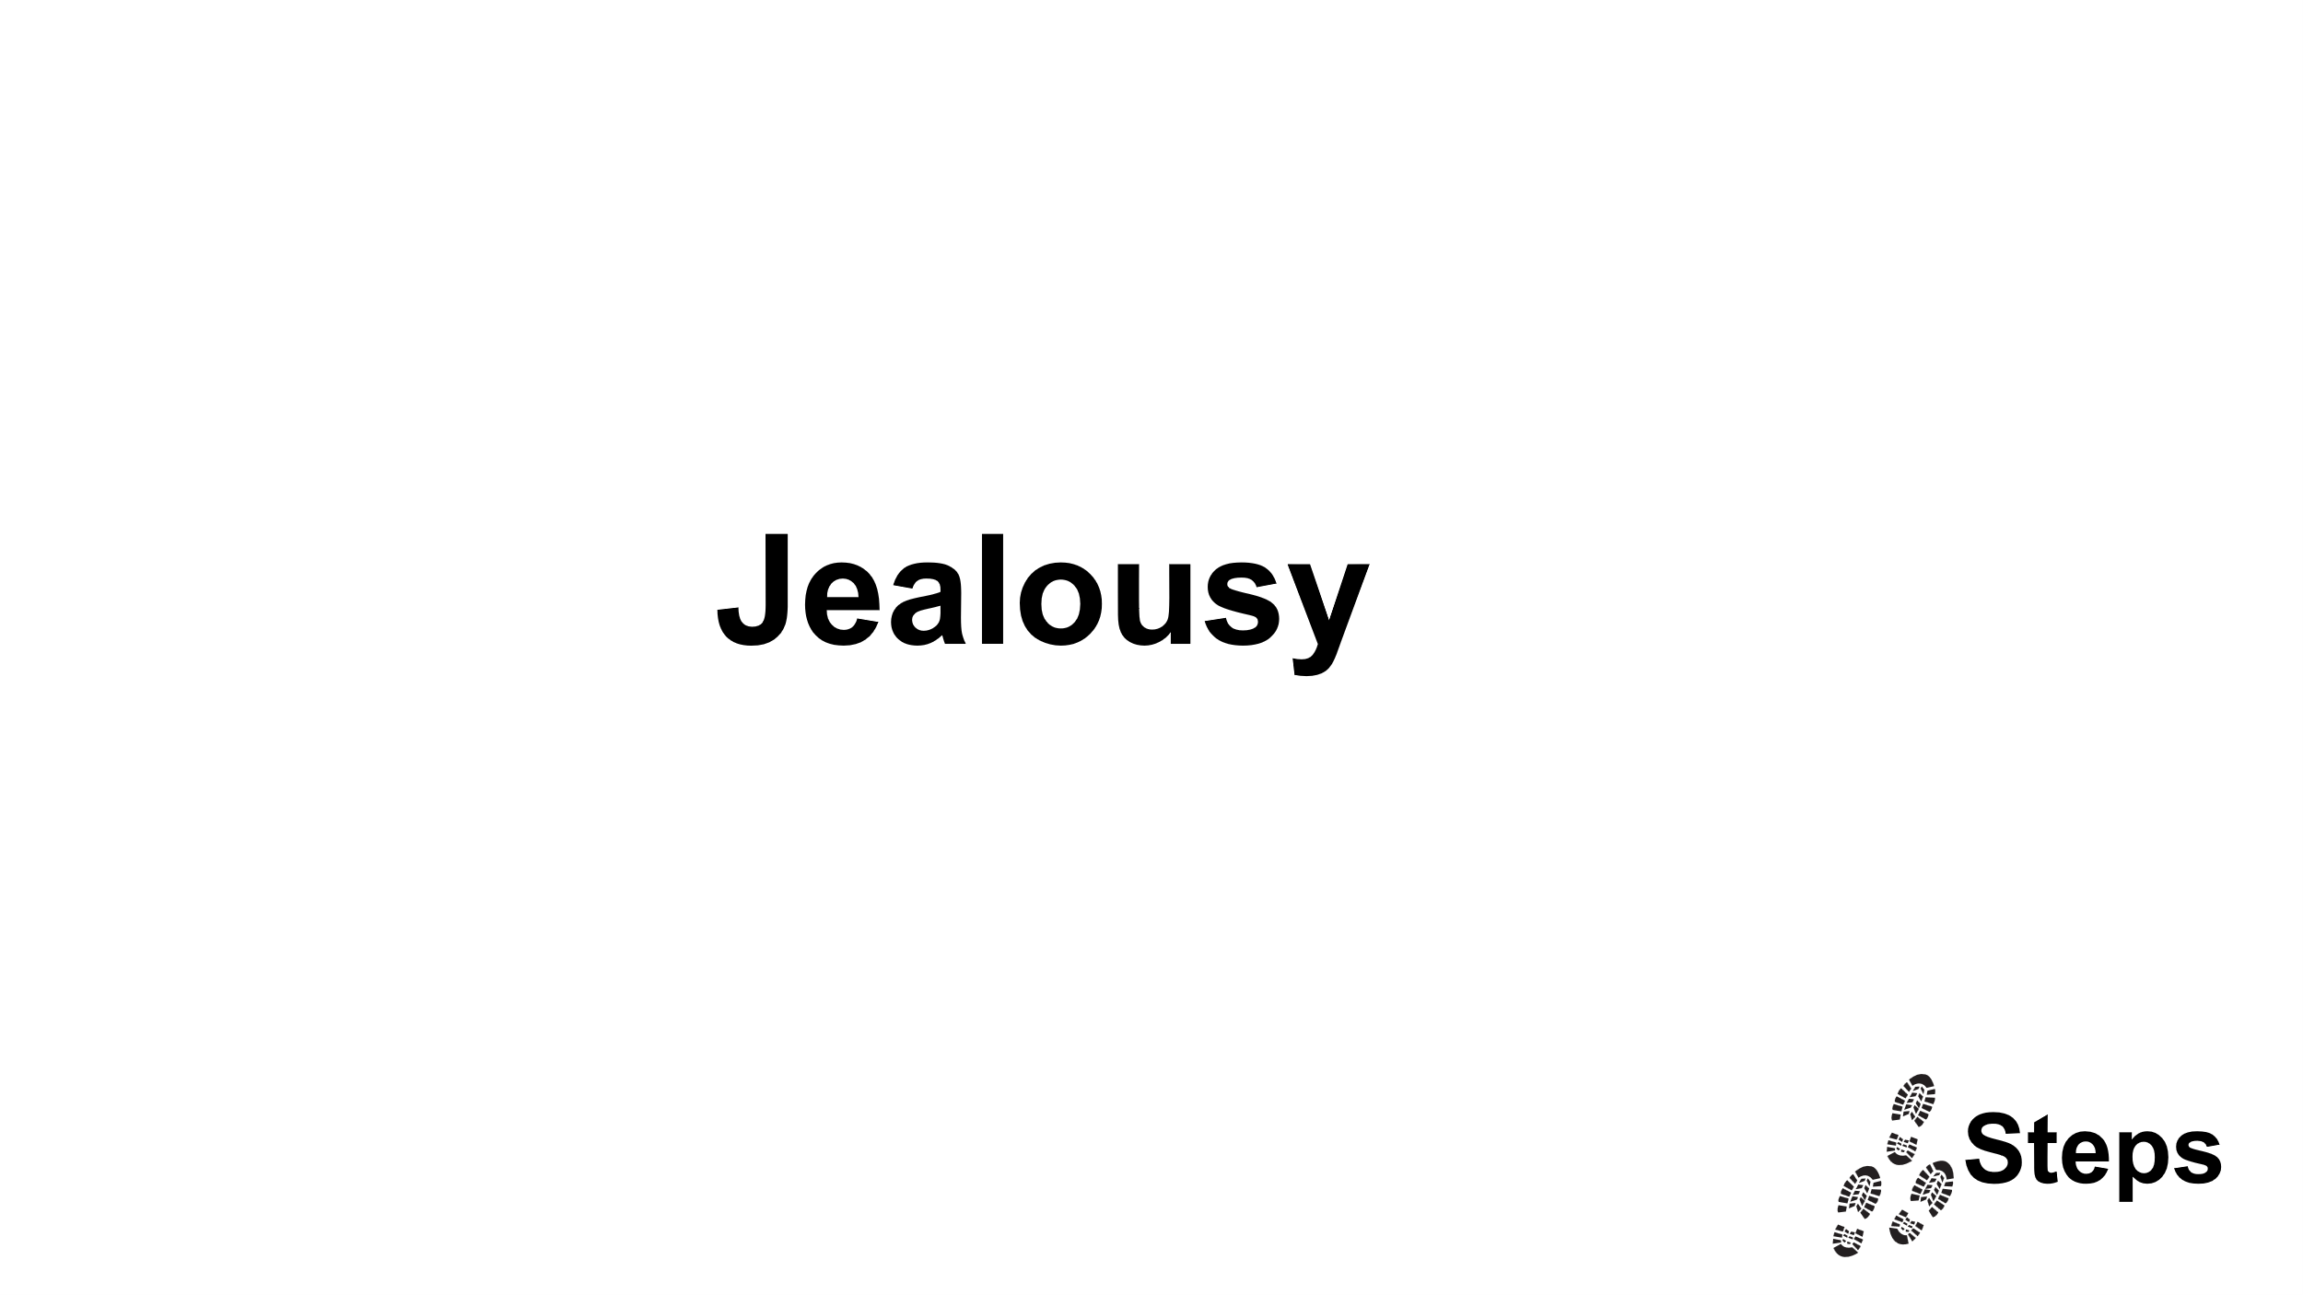
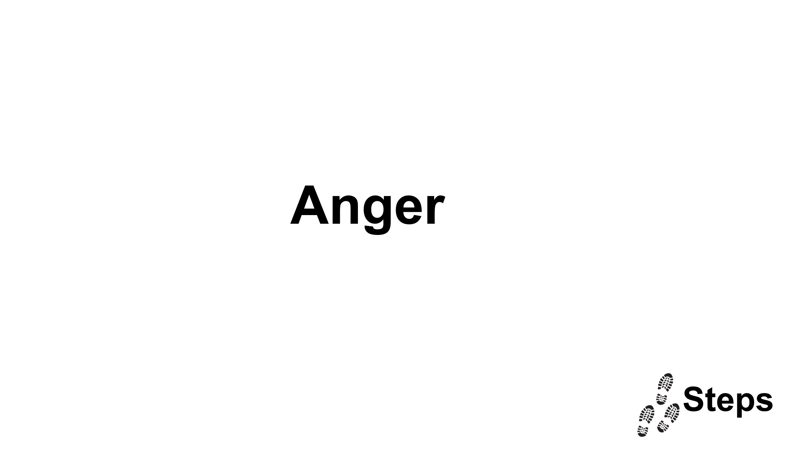

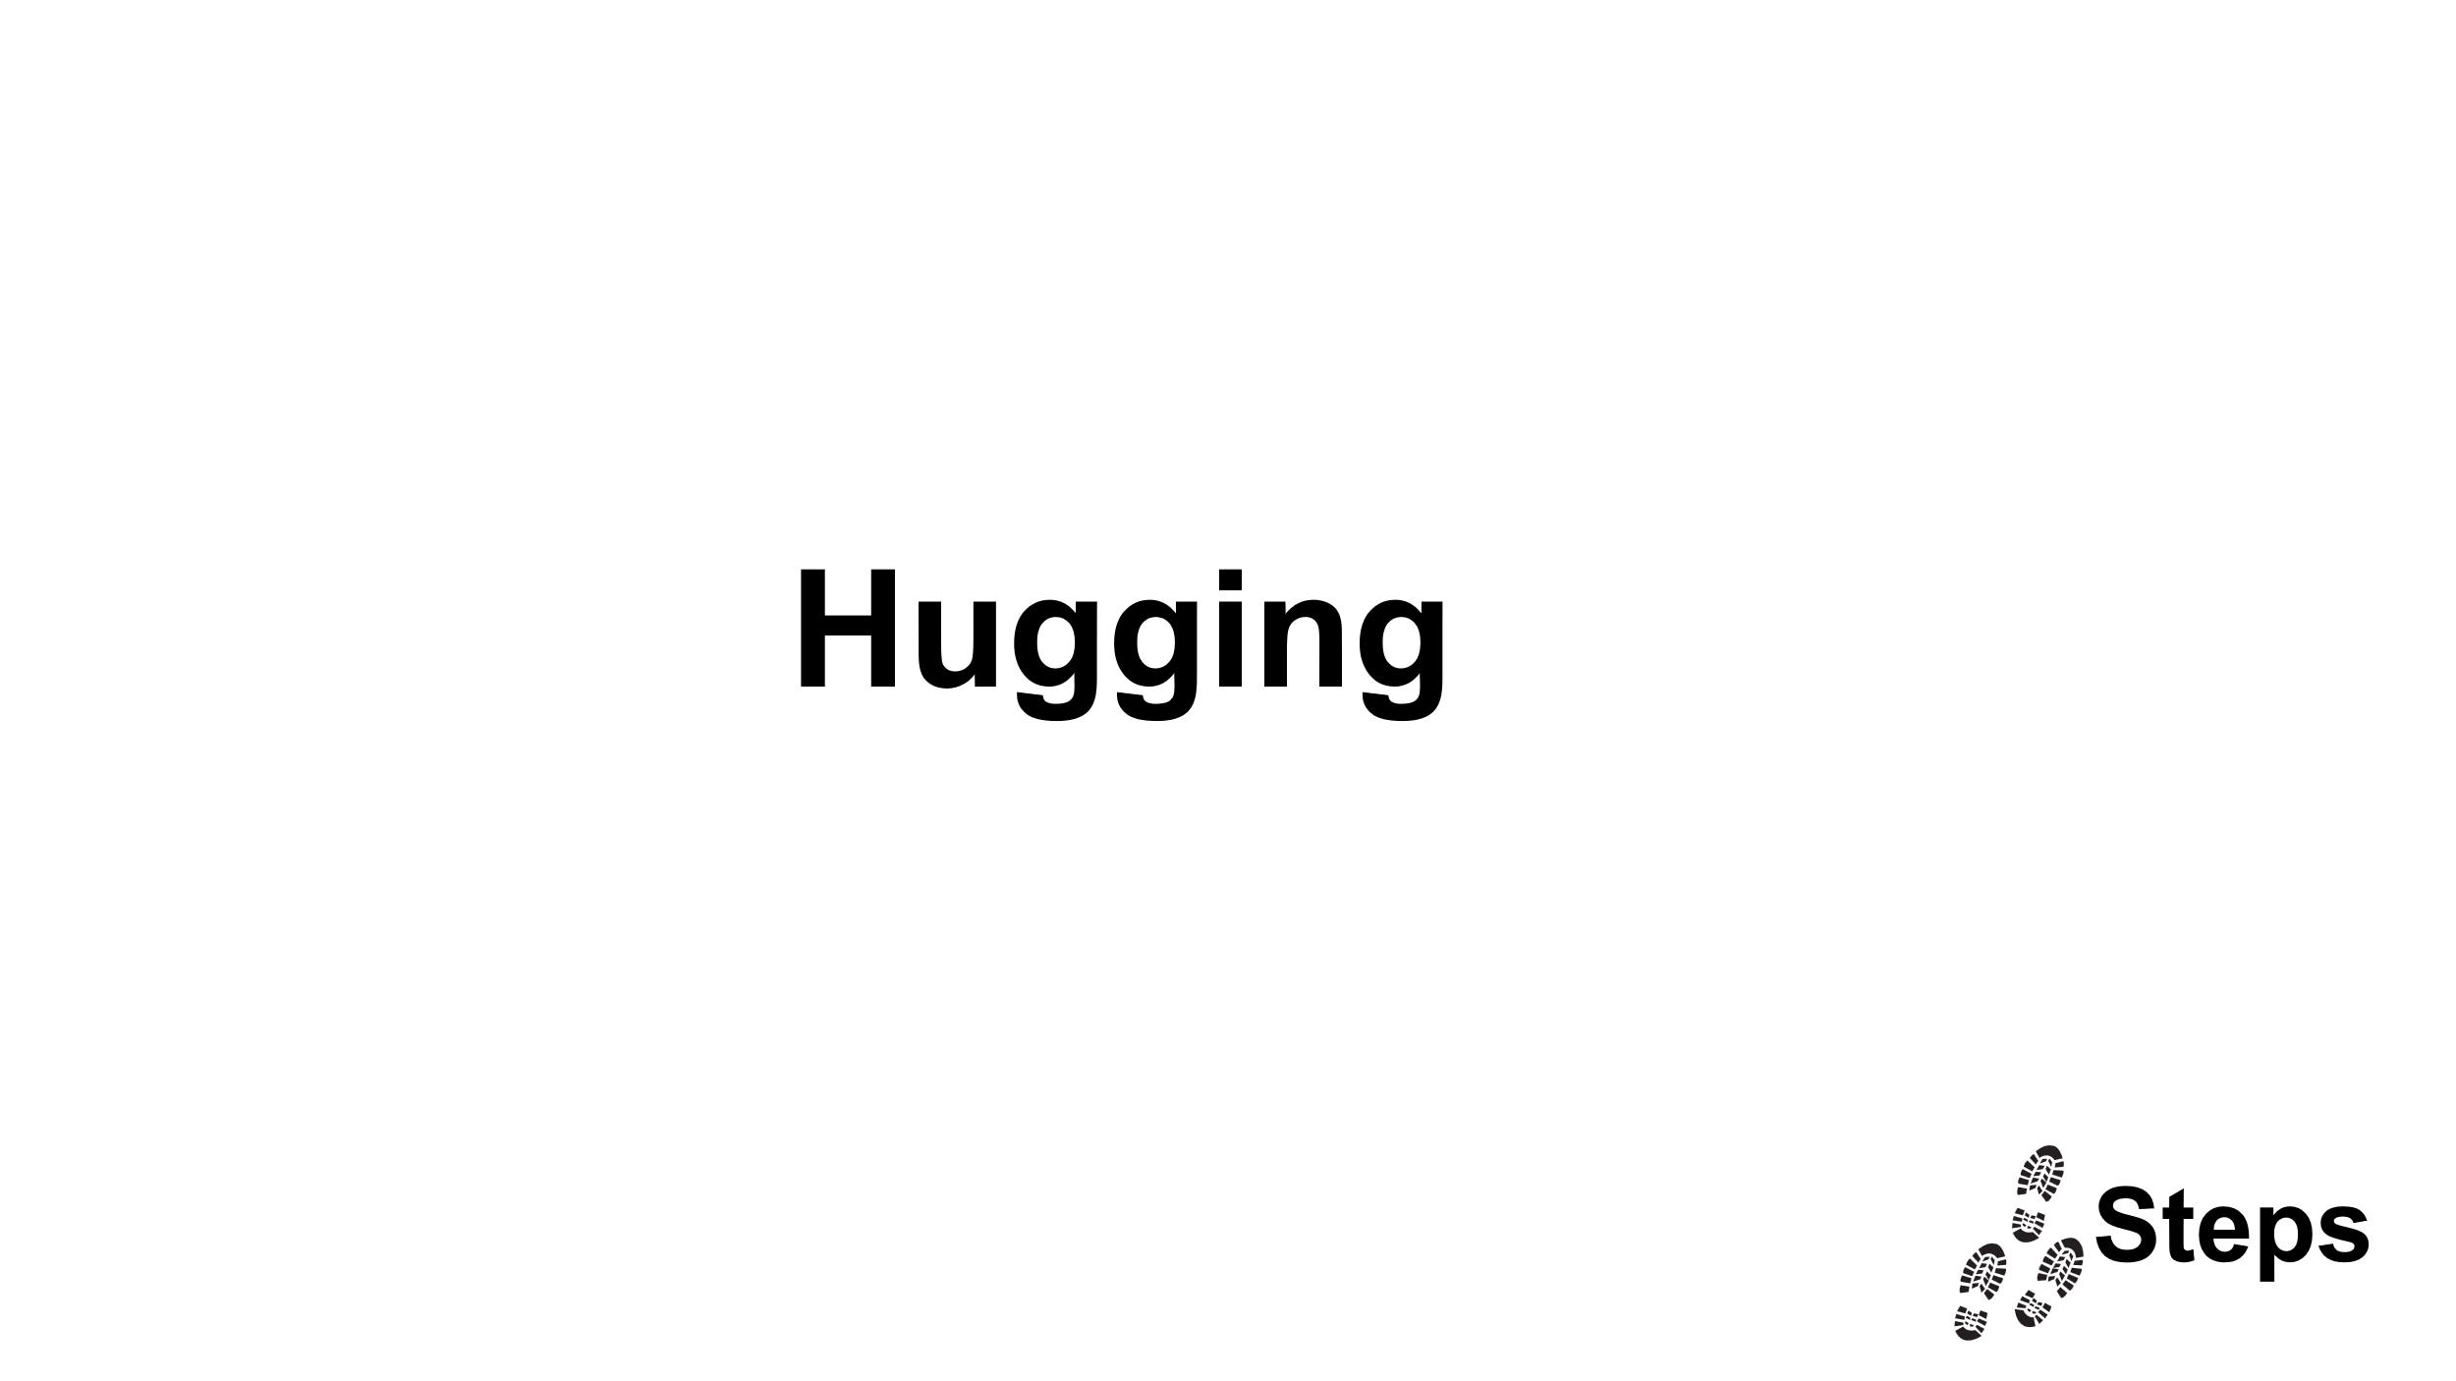

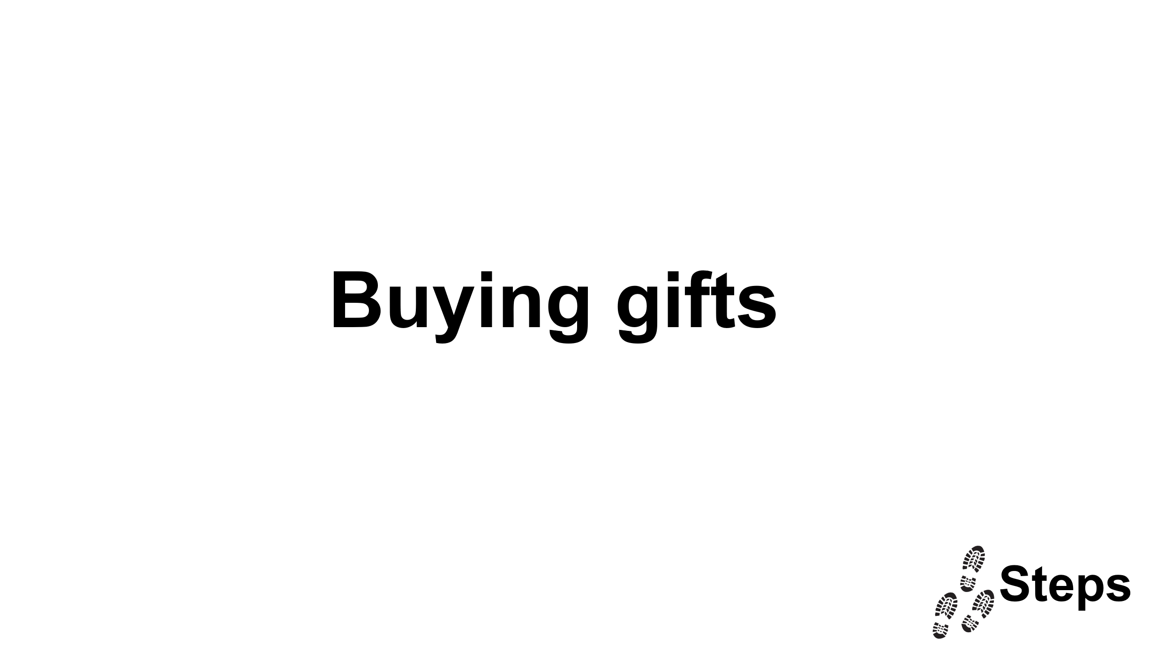

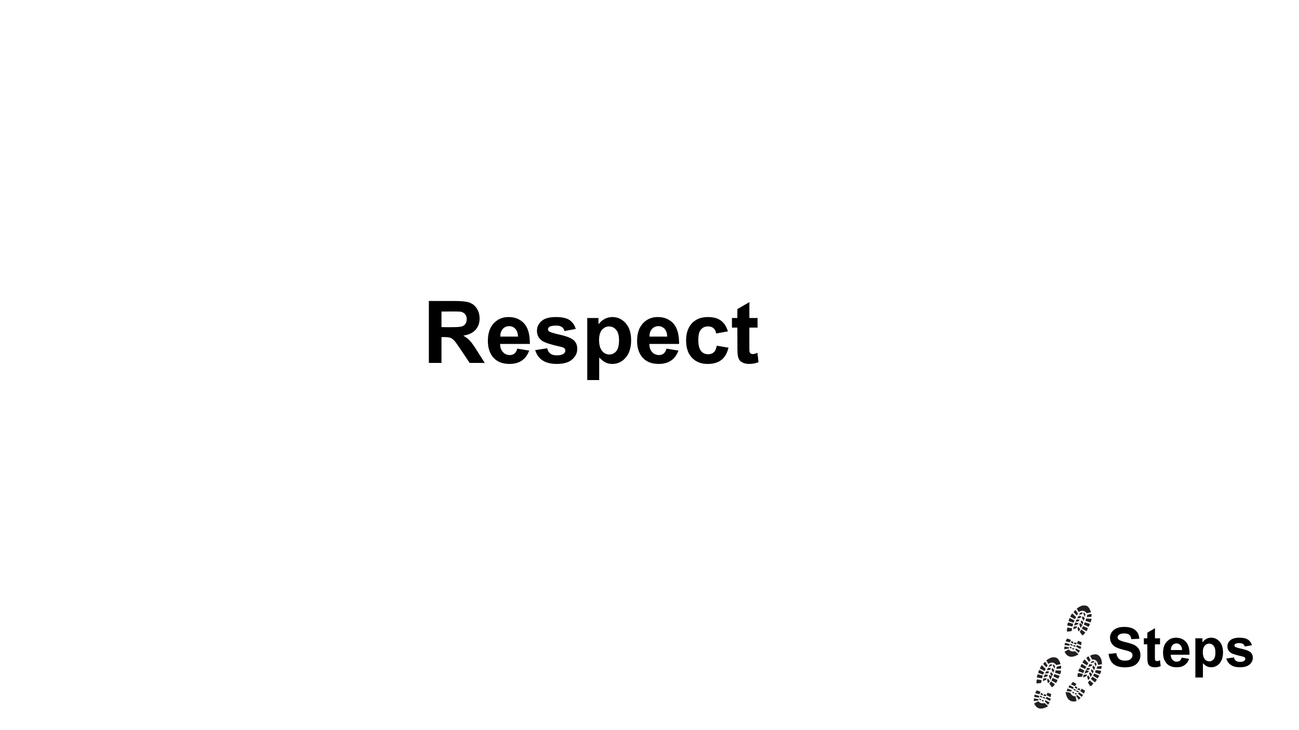

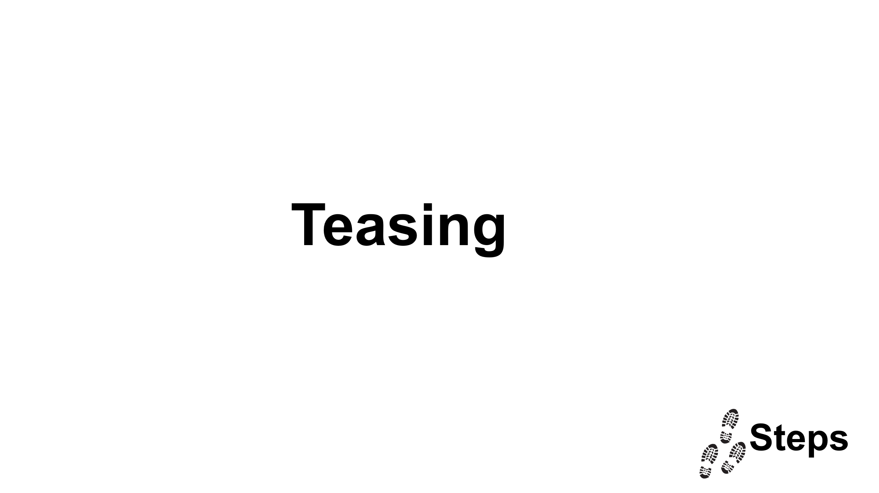

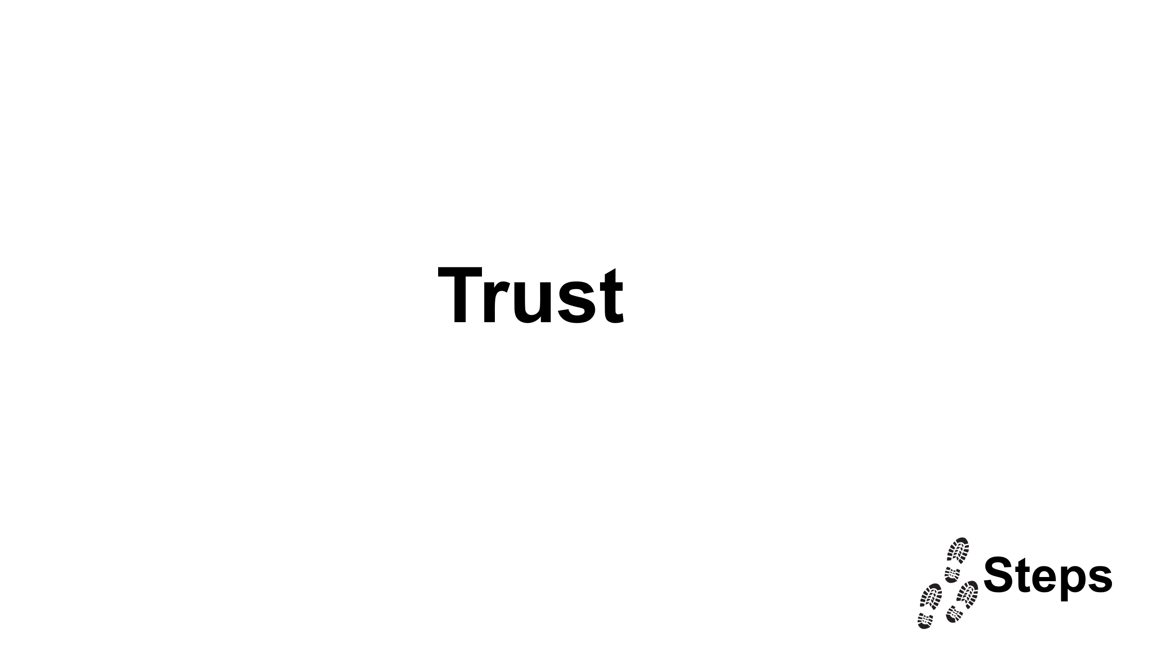

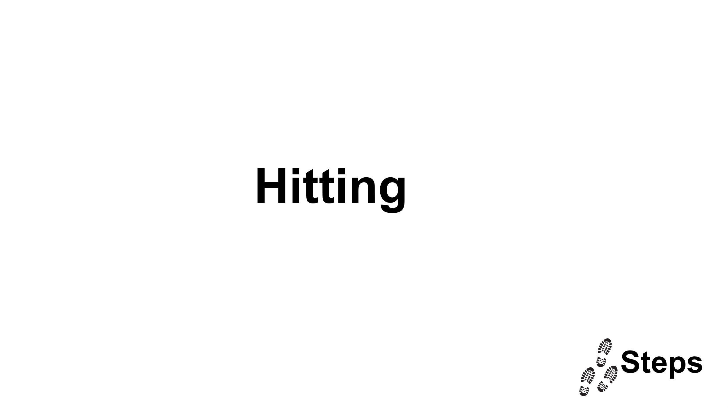

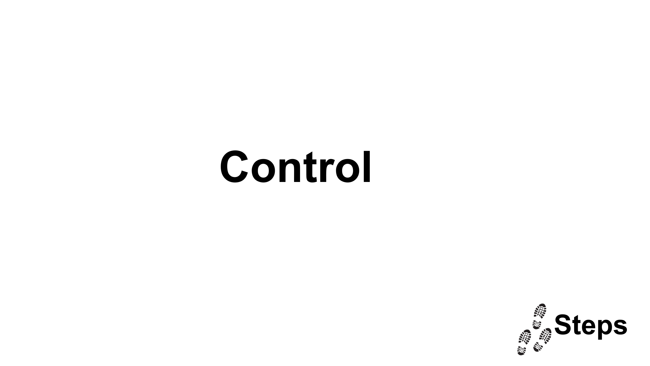

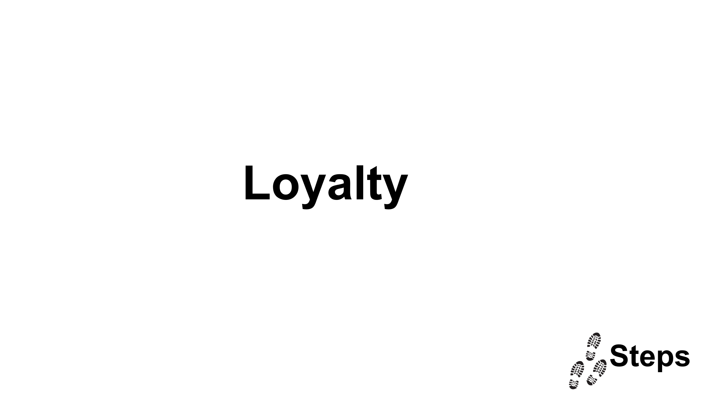

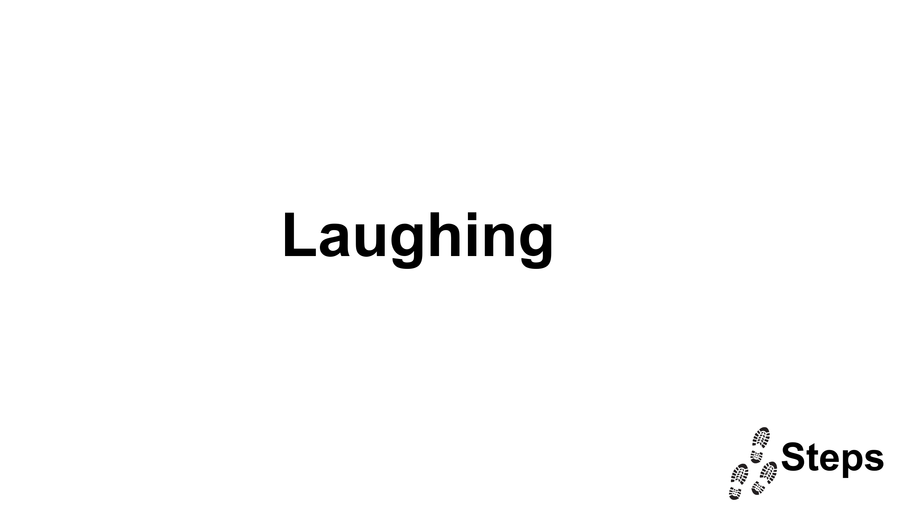

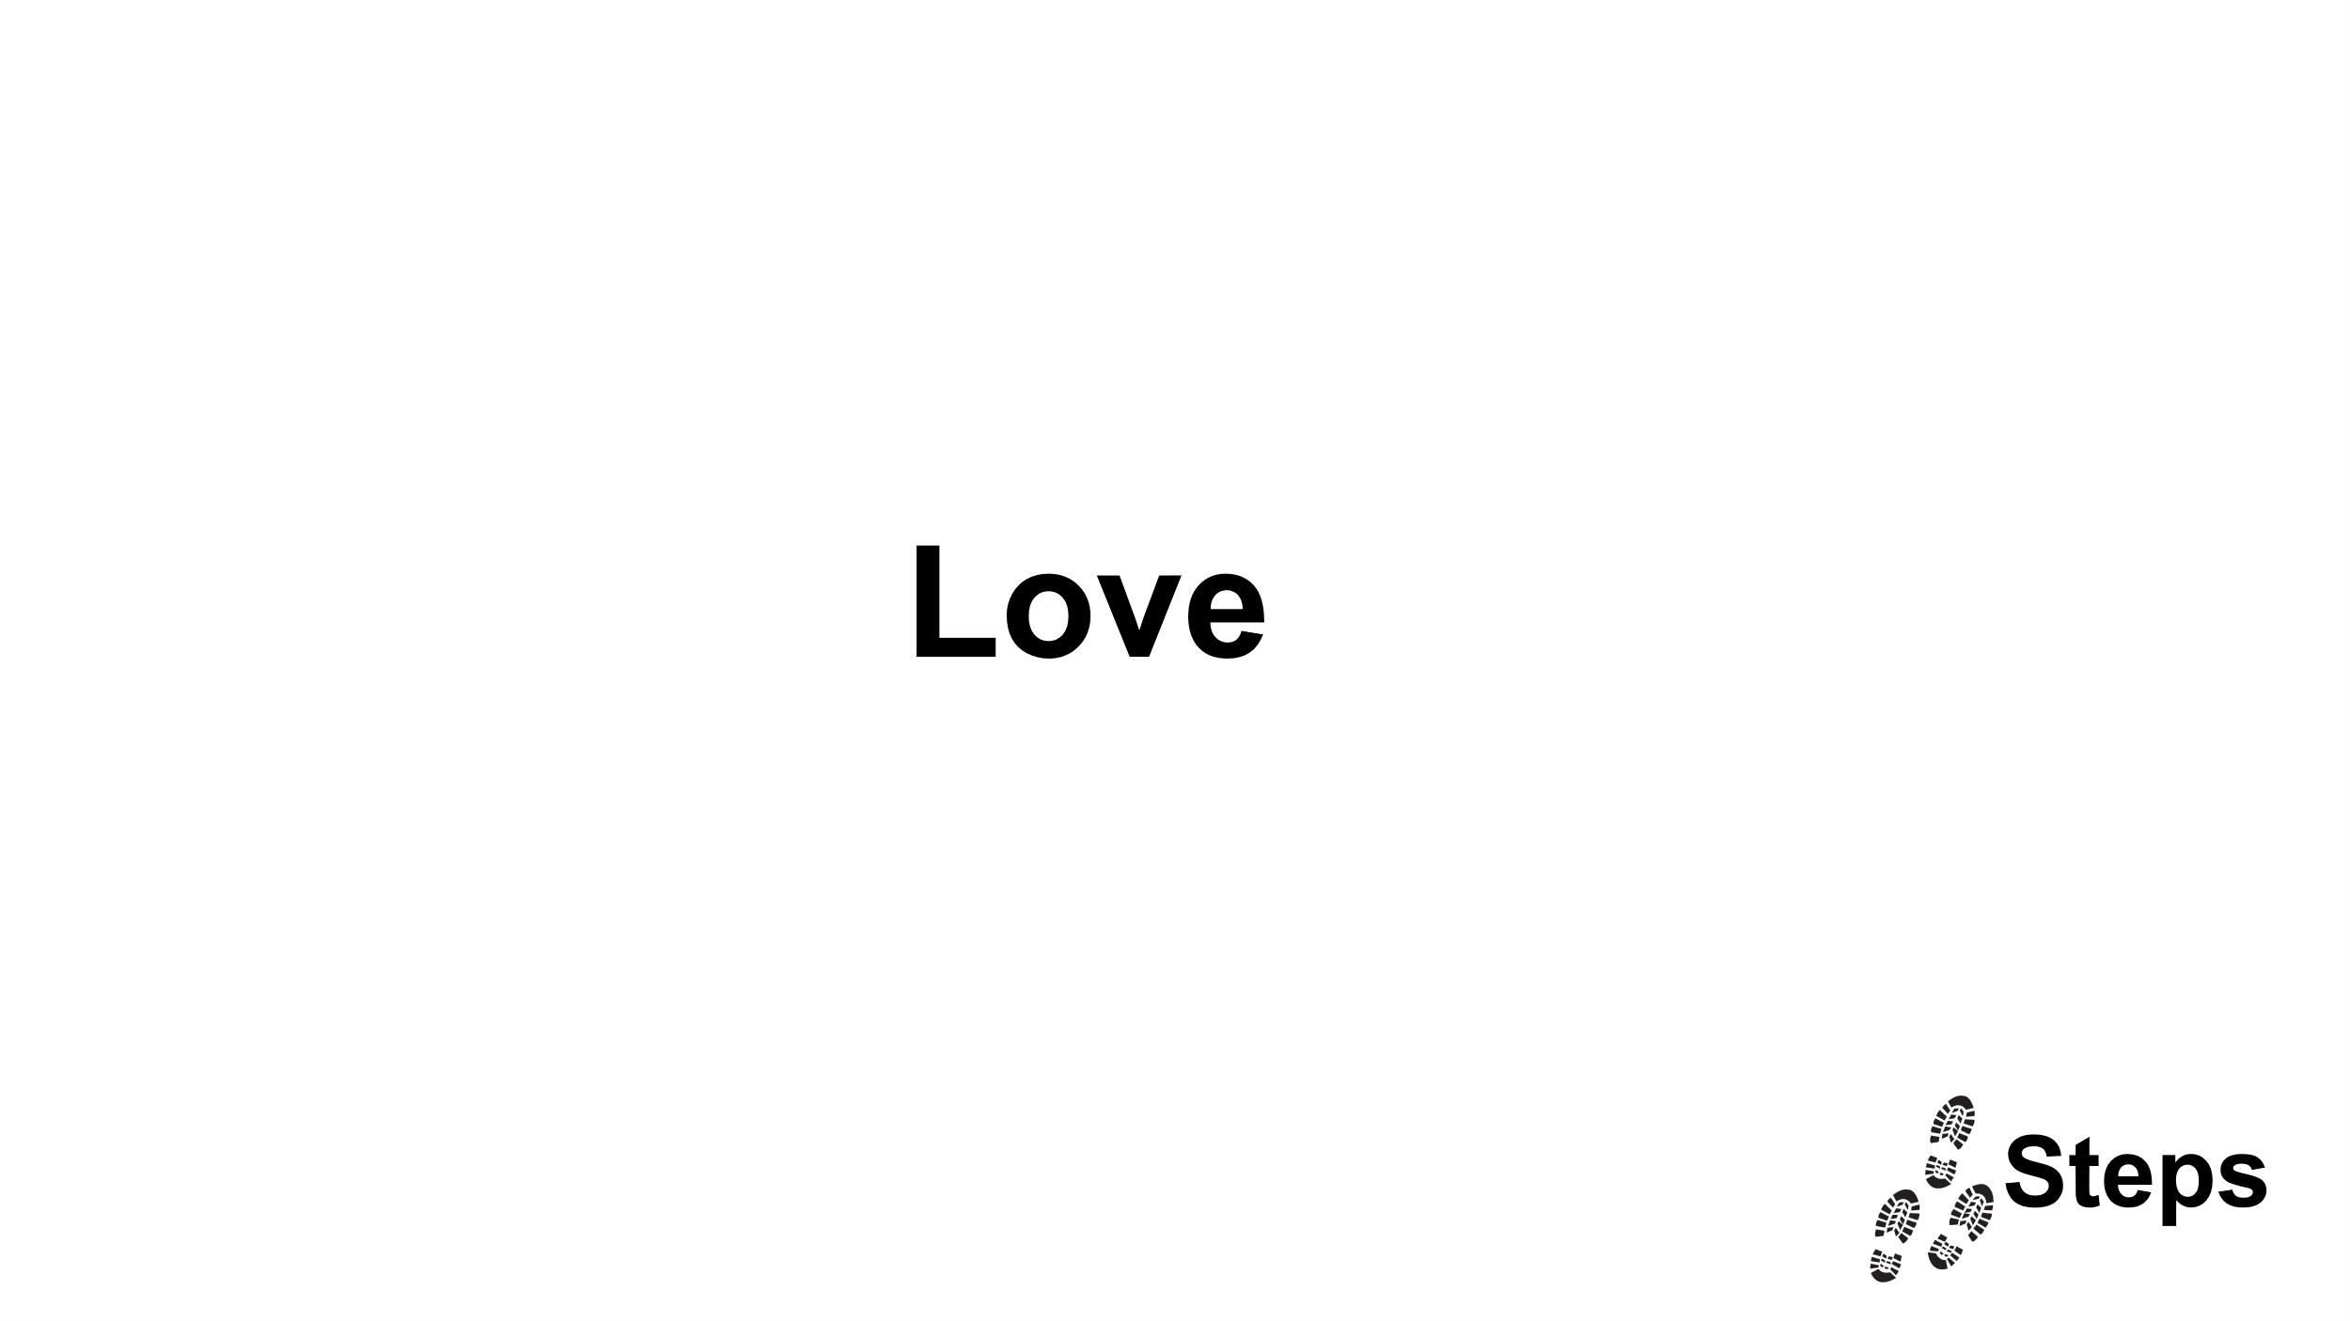

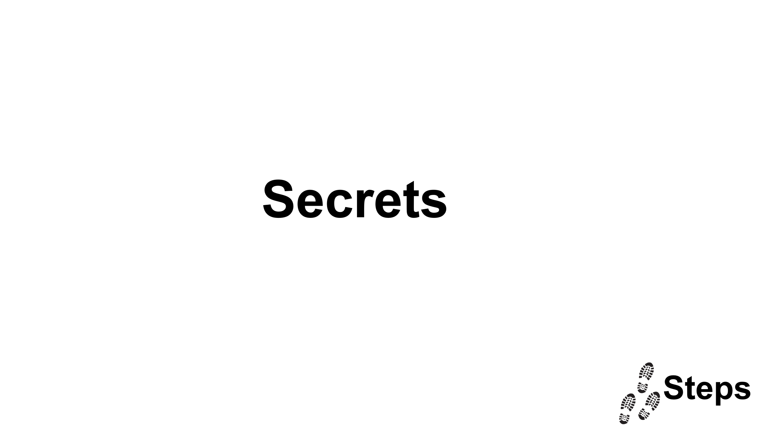

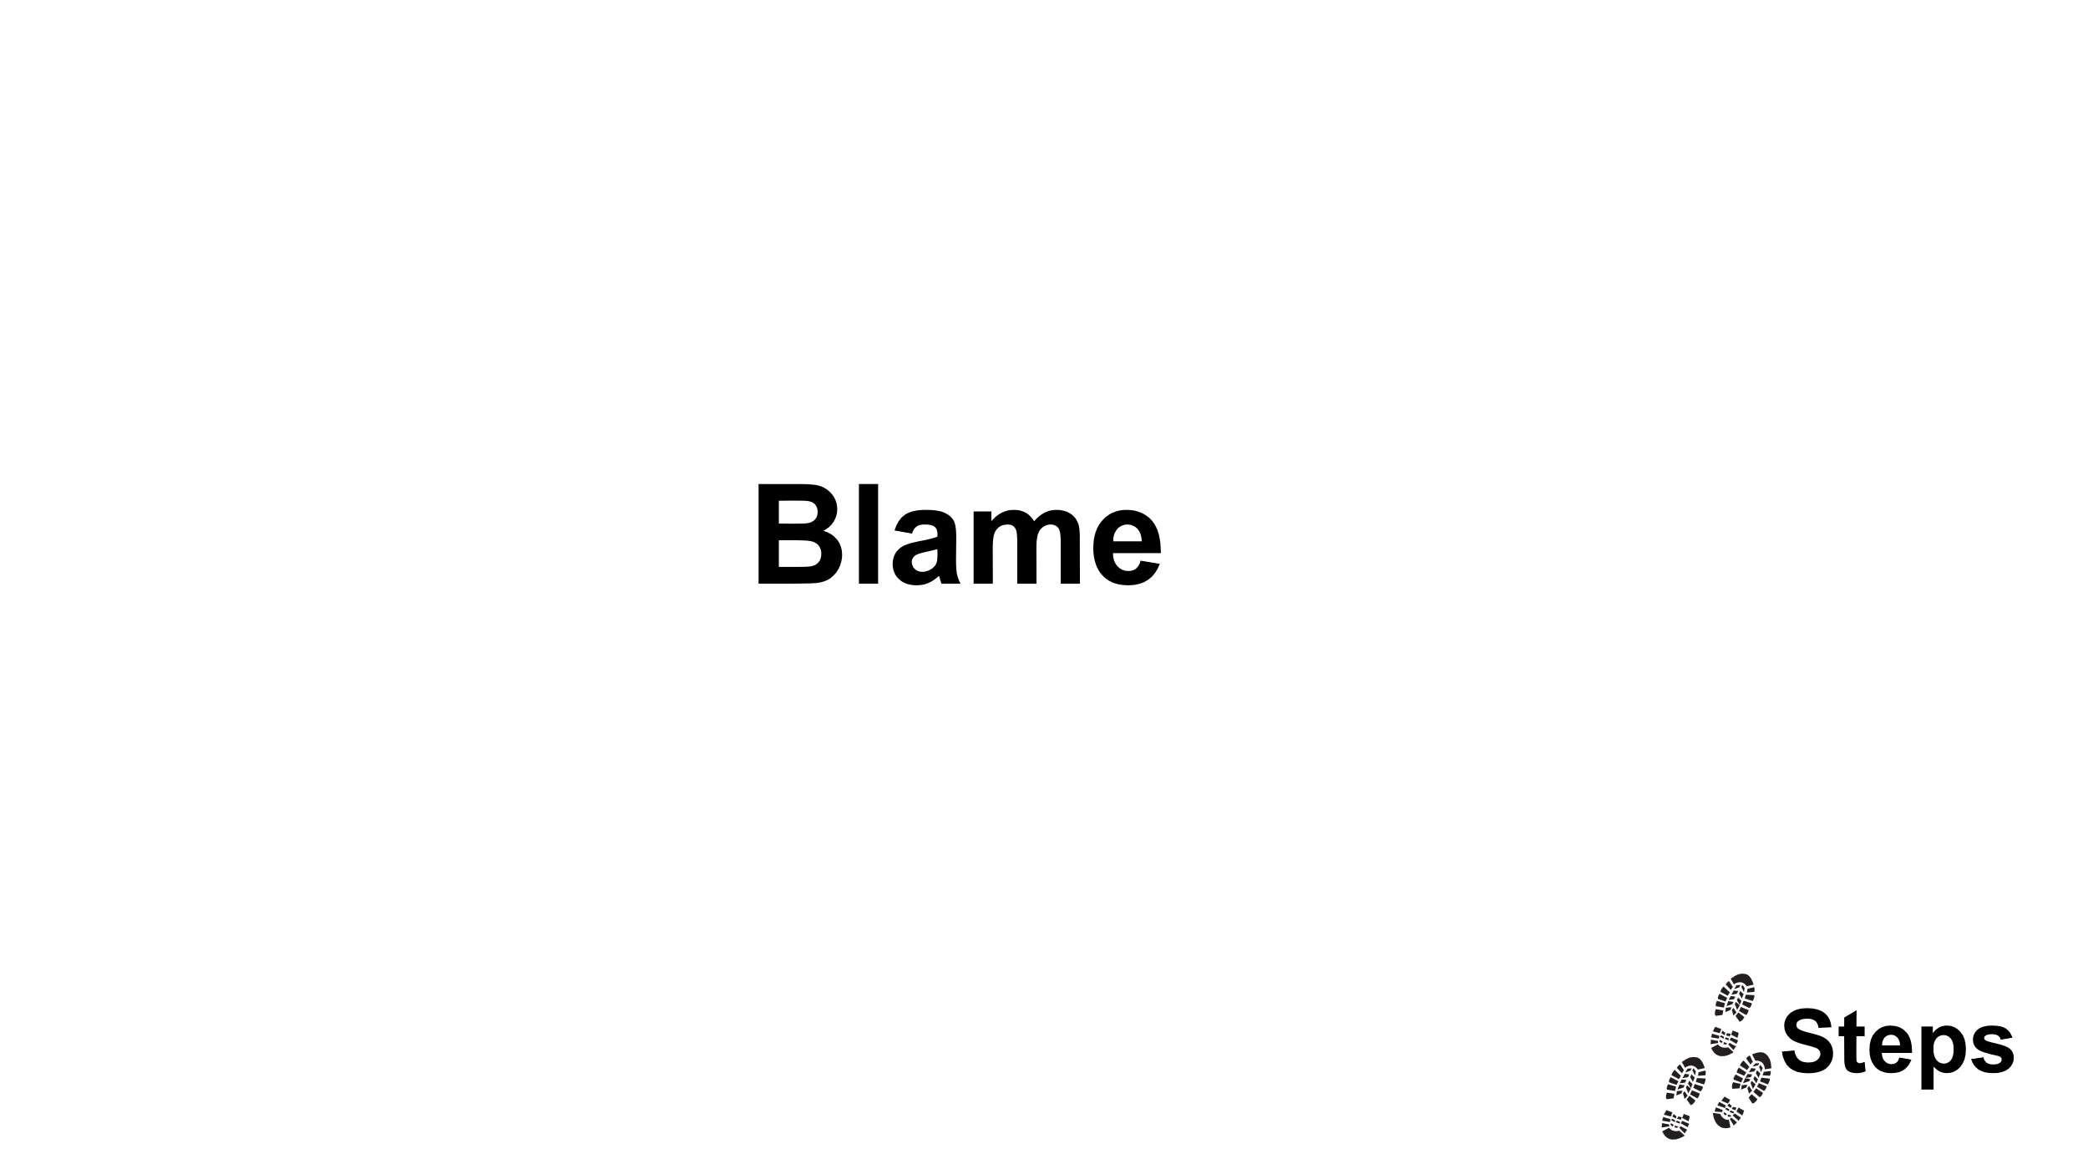

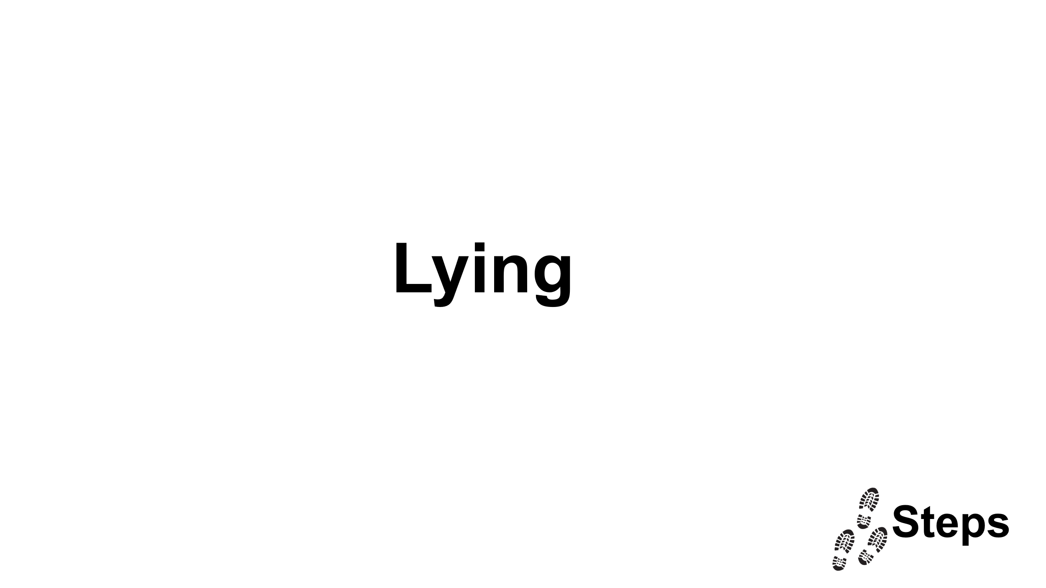

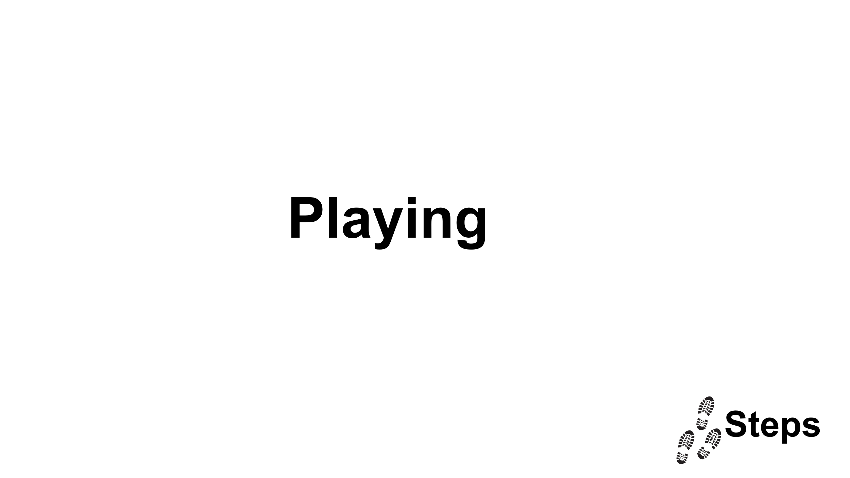

RESOURCE 2

Scenario One
John and Sam have been texting for 3 months. They have each other on Snap Map. Sam has been checking when John is active on Snapchat and feels annoyed if he hasn’t replied to his texts but has been online. He also like to check where he is. Sam asks John why he doesn’t respond when he’s online.
On one occasion Sam is looking where John is and asks John why he was out and who he was with.
During an argument, Sam brings this up again and says John keeps ignoring him and if he wants to end then they should. John doesn’t know what to say and feels uncomfortable that Sam has been checking his location.

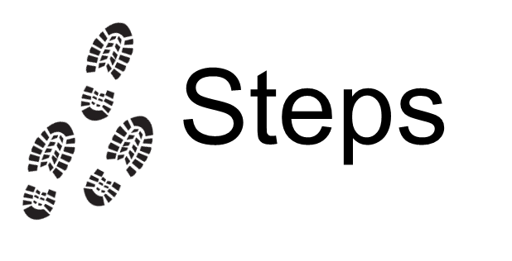

RESOURCE 2
Scenario Two
Jack and Eve are dating and tease each other in private. Jack says, “You are punching.” Eve laughs and it has become an inside joke.
Eve and Jack are with their friend group at school at lunchtime. Jack, in front of everyone says to Eve, “You are punching, you know that?” Everyone laughs. Eve laughs as she feels uncomfortable but now feels insecure that everyone thinks Jack is better than her and she is lucky to have him.
Eve tells Jack in private she felt uncomfortable about what he said in front of their friends.
Jack says, “Can’t you take a joke? You are so sensitive.” Eve doesn’t want to appear like she can’t take a joke so she says nothing.

Session Two
Learning objectives:
- To understand the concept of hypermasculinity and how it can be harmful.
- To understand the impact of this on men’s health.

Facilitator guidance
Introduction
The facilitator should encourage the pupils to recall words they may have heard in the universal sessions: stereotypes, misogyny and algorithms. Key learning for the pupils is that they are able to identify what misogyny means and what behaviours might constitute as this:

- “Misogyny is prejudice, negative opinions or irrational hatred of women and girls.”
- “Someone who is misogynistic will hold views and show behaviours that are emotionally and physically harmful to all women and all girls.”

Using Resource 3, ask the pupils to match the words to the statement.

Phase One
The facilitator should ask the pupils to think about what masculinity is – is it a set of behaviours, attributes and roles associated with boys and men. It may be helpful to record these on paper or on a word cloud.

The pupils will have explored a video in the Universal sessions on The Rise of the Aggro-rithm. https://www.youtube.com/watch?v=qGASUCP-YLI

Show the pupils the video which they will be familiar with. This is an opportunity to pick out all the expectations of what masculinity should be in greater depth. There are some key elements to pick out within this: views on women, views on how boys should look, views about how it is acceptable to talk to women.

Introduce the concept of hyper-masculinity. Ask the group what they think it means.

Explain that hyper-masculinity is exaggerated male traits such as aggression, emotional suppression and dominance and that these are often at the expense of healthier expressions of masculinity. When this emphasis becomes overwhelming, as it does in the video they have just watched, it means that you are more likely to show disdain towards others who have “feminine” traits. It is seen as being weak.

Explain that in order to exaggerate male traits, women and girls often play a weaker role. This helps to shape views about women and girls.

Explain that online the algorithms direct you towards certain elements – it makes guesses about you even based even on how long you linger on a video. Resource 4 recalls information from the universal sessions which is useful to share with pupils again at this point.

Ask the group if they can think of any examples where hyper-masculinity is demonstrated online. Guide them towards thinking about examples they may have seen, for example:

- Gym buddies who will do anything for each other.
- Gym buddies who film in the gym and make fun of people who are less masculine than them and/or overweight; or of women who are exercising.
- Rejecting emotions and crying as “feminine.”

Explain how sometimes this hyper-masculinity can turn into misogynistic behaviours. To be more masculine, you have to have someone who enhances your masculinity. Examples of where this can turn into misogynistic behaviours may be:

- Calling women “sluts” or “whores.”
- Videos that make a joke about women being untrustworthy or unreliable; or videos that suggest women should do what a man says; videos that normalise physical violence against women.

Spend some time focusing on the discussion around this. It may take some time to unpick the views that the pupils share. Remember – this is not an end point and, as educators here, we are not looking at creating an epiphany moment – we know that children’s development is influenced by a number of factors. What we are hoping to do is to ensure that pupils have knowledge around this and a space for them to discuss.

Link back to the understanding around respect and consent:

- We all hold an element of personal responsibility to the other person in a relationship.
- We can make people’s lives better through showing respect: for other’s choices (what they want to do); for other’s identity (who they are); and, other’s boundaries (what they don’t want to do). If we do this, we are providing the elements that make up a person’s ability to give consent.
- That through being connected and respecting others it builds healthy relationships and supports our own wellbeing.

How can the views around women and girls shared by some hyper-masculine content respect others and support our own wellbeing?

Phase Two
The facilitator should ask curious questions to encourage the group to think:

- If we were to focus solely on developing our physical strength, what would the positives be? What might be a negative impact? What might be lost if all our time was spent in the gym?
- If we were to suppress our emotions, how might our behaviours change? Is this healthy?
- If we were to look down on other people for being feminine, what would the impact be on them?
- If we are to think of women and girls as less than men, what might the consequences be? On women and girls? On our ability to form positive relationships?

The facilitator needs to be able to move the conversation forwards to what would be more positive:

- The benefits of physical exercise to support us to be mentally healthy is well known – what could we suggest as an alternative to the vision that is exaggerated in hyper-masculinity?
- There is a need to regulate our emotions when with other people, what strategies can we use? How can we use the people around us to help us?
- What would be the benefits if we were to respect each other for their choices, identity and boundaries? What would this look like in school? What would it look like online?
- What do men and women have in common? What are the positives we should celebrate?

Finish by reminding the group that there are lots of positives about them and we should be able to highlight their positives whilst acting to support others.

RESOURCE 3

Prejudice, stereotyping, or discrimination, typically against women on the basis of sex
Internalised beliefs about how people in different groups should always be like or look like
Prejudice, negative opinions, or irrational hatred of women and girls
The ability to influence the behaviour of others
Qualities or attributes that are seen as characteristic of men
Stereotypes
Sexism
Misogyny
Power
Masculinity

RESOURCE 4
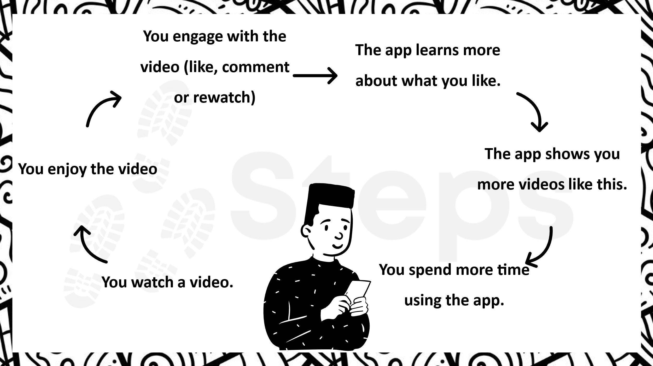

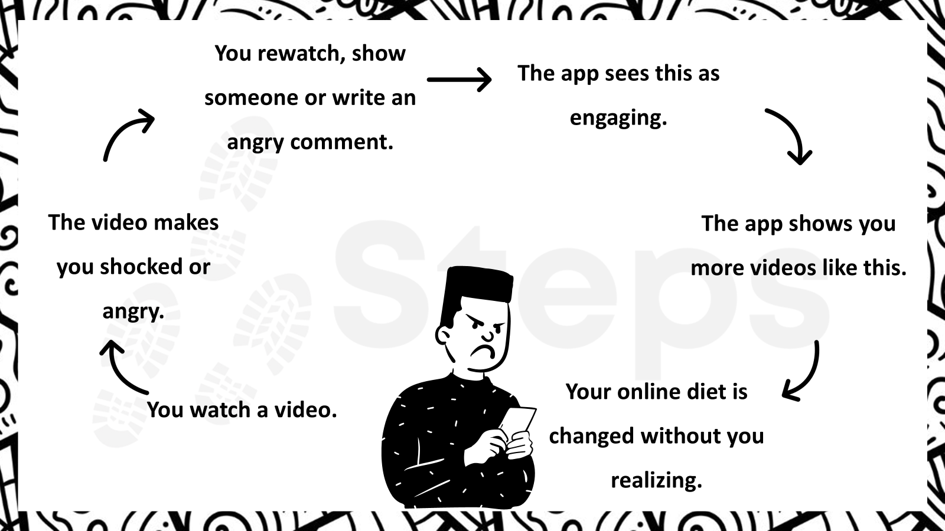
Session Three
Learning objectives:
- To understand the way misogyny is manifested online.
- To understand the impact of online misogyny and begin to recognise how they can respond to it.

Facilitator guidance
Introduction
The facilitator should open up a conversation about the social media platforms and gaming platforms they use and what they enjoy about them. Draw out the positives they experience from the online world but also ask them about the negatives they see. Ask them to think about if any of the negative behaviour they see can have a detrimental impact on others.

As the conversation develops, ask the pupils if they have ever seen sexist or misogynistic content online. Remind the pupils of what misogyny means: the dislike, contempt, or ingrained prejudice against women. The pupils may say they have never seen it but allow them to converse – they may just not recognise it.

Ask them if there are any influencers or celebrities who promote misogynistic content who they are aware of. Remind them of the work from the Universal Sessions that highlights how they get paid for higher user interaction. The resources from the previous session may be helpful here.

Phase One
The facilitator reads out a series of comments that are made online – encourage them to talk about if they have seen things like this, if it is something they see regularly and if it happens more on certain platforms i.e. gaming platforms. Encourage the boys to talk about how they feel about the language that is used – does it make them laugh, does it make them feel a bit awkward. Ask them if they respond to similar comments or just ignore it.

Tweet: “Make-up should be illegal, it’s only purpose is to deceive and lie to men, how will I know the true value of a woman if she slathers herself in paint everyday.”

Comment: “This is all women want to do these days, take selfies and stare at themselves.”

Gaming thread comment: “Women should be at home looking after men and not playing football.”

Encourage the children to think back about respect from Session One and Session Two – are these comments showing respect for others. Encourage them to think about if there is any difference between what is said online and what is said in person.

Phase Two
Resource 5 is a print out of a series of comments – encourage the children to think carefully about what harmful stereotypes or messages are being promoted. Ask them to think about what could be harmful about this.

Following on from the pupils looking at the resource, the facilitator should highlight certain aspects of the tweets that are part of the online misogynistic world. Explain that these are used over and over again in online misogyny.

Tweet 1 – The tweet contains sexist stereotypes and reinforces harmful beliefs about gender roles – what are these sexist stereotypes? Why is this harmful?
The hashtags and emojis downplay the severity to make it seem like a joke which is a common tactic used in the online misogyny world – is this something they’ve seen? Where someone says something that is cruel about another person but uses hashtags and emojis to make it look like a joke?

Tweet 2 – This tweet devalues women’s opinions and reinforces stereotypes that women’s roles are limited to superficial topics – What might happen if we dismissed other people’s opinions? What can we learn from others?

Tweet 3 – This tweet invalidates feminist perspectives and dismisses women’s issues as “whining” or seeking attention – a common way of working in this world is to suggest that a lot of online misogyny is focused around the idea that women are untrustworthy, unqualified, unintelligent and unlikable.

Tweet 4 – This tweet uses slut-shaming to police a woman’s choices about her appearance and how she’s expressed herself online – this is likely to be an interesting discussion, help to draw pupil’s back to the idea of respect for others.
The phrase “Have some respect” implies that a woman’s worth is tied to her modesty and that her value is diminished by her choices – where might the girl be getting pressure to post pictures of herself in a bikini? What might she be seeing that influences her choices? Does respect for others mean that we look down on them for their choices?

The final tweet can be used to discuss the dynamics of how misogyny is often framed as “truth-telling” or “just being honest” to mask its harmful intent. Encourage the pupils to think about how this language online can affect the way we behave in real life.

It’s important through this that the facilitator encourages an open conversation. This isn’t about trying to shut down conversation or tell them that they are “wrong” in their views. It’s about allowing the pupils to talk and then showing them that there are certain ways of operating in the online world that gain more traction and that these can be used by people who want to depict harmful portrayals of women and girls. Encourage them to understand that this also hurts themselves.

Phase Three
Within this last phase, we begin introducing information about being an active bystander. Ask the pupils what they would do if they noticed misogynistic behaviour. Explain that the purpose of the work today has been to help them to notice. Ask them to think about if there is a need for action – explain that by adding emojis or doing likes reinforces what the person has said. It may be that they decide to take action. This could be:

Report and Block: Teach participants how to report harmful content on various platforms.
Speak Up: Encourage respectful calling out of bad behaviour if safe to do so.
Support Victims: How to offer support to those targeted by misogyny – this might mean reaching out if you have noticed the behaviour.

Go through the tweets again – what might you do if you were to take action.

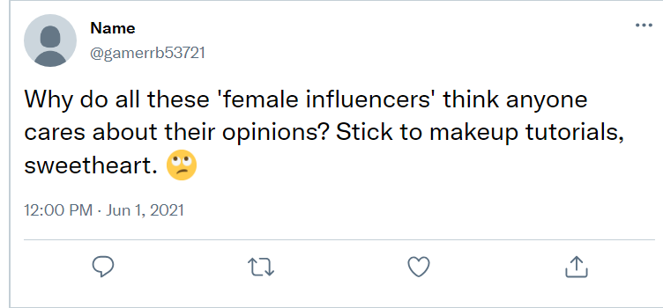
TWEET 2
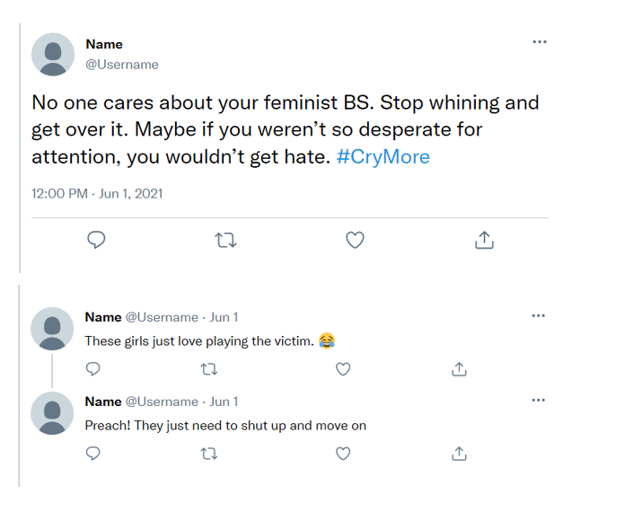
TWEET 3

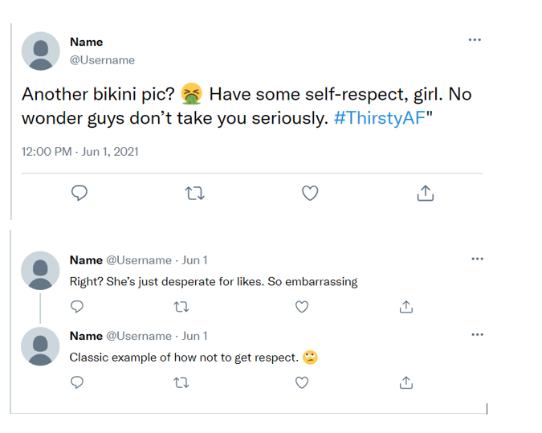
TWEET 4

Additional session
This session is available for Secondary School pupils or where it is deemed appropriate by Senior Leaders.

Learning objectives:
- To understand the impact of online pornography.

Facilitator guidance
Introduction
Begin by recalling the work that was undertaken in the previous session around online misogyny. Explain why toxic online behaviour may have more of a negative impact on women and that the types of behaviours explored in the last session can turn into direct harassment.
- 65% of women who game have reported an instance of sexual harassment (Sexual harassment: can be ‘stand alone’ and can be verbal and non-verbal. Could be sexual comments, upskirting or unwanted sexual touching).
- 1 in 5 women experience abuse or harassment online. (Often, the way women are portrayed when they are abused online is that they are untrustworthy, unqualified, unintelligent and unlikable. Untrustworthy is an overarching concept for slut-shaming and victim-blaming).
- Women are 27 times more likely than men to experience abuse or harassment online.

Ask the group why they think this behaviour is so common online compared to face to face interactions. Explain that we can become lured into thinking that the person whom the abuse is directed at isn’t a ‘real person.’ This means online we are less likely to intervene because we don’t feel as emotionally connected to the person – to intervene, we at first need to notice, then we need to feel empathy, moral engagement and a sense of responsibility; because our actions online are not synchronous and in person then we forget there is a real person whom the abuse is directed at.

Explain to the group that not seeing the person whom the abuse is directed towards , or feeling a connection to them, also has an impact in the way that we see online pornography – we can become desensitized.

Phase One
It’s important that the facilitator explains that in this section we aren’t talking about their personal experiences but we are going to try and look at this in an objective way. Explain that it may be awkward in parts but share that the benefits of talking helps them to understand a little more.

The facilitator asks pupils what is porn and what the purpose of porn is. It is likely that this will elicit a series of ‘funny’ answers and probably some shared hilarity. It’s important that the facilitator doesn’t respond to this but instead asks the follow up question: what if we are looking at porn from a Violence against Women and Girls perspective? It is likely that some pupils will allude to some online female creators (at the time of writing, it may be that they highlight people such as Bonnie Blue and Lily Phillips but this will change over time). If this is the case, it’s important that the facilitator looks at this from a respect position – are the people they are using for their content having respect shown for them? Who is making the money from this – will it be these creators?

Phase Two
This phase of the session is to guide the pupils through a series of questions that encourage them to share their thoughts. It’s important that we ask subsequent questions if we feel there are some concepts that need greater depth. These are in italics. They have been designed to build up so that the concepts are introduced gently and encourages pupils to see this for themselves.

- What is the representation of women in porn?
- Does it perpetuate stereotypes? What kind of stereotypes might these be? Can stereotypes be harmful? Why?
- Are there motives behind the online content? Who will be making money out of this?
- Does it promote consent and respect? Think about what we have learnt about respect – is this portraying a realistic depiction of respect?
- Does it promote healthy attitudes towards sex? What is your reason for this?
- How could watching a lot of online pornography be harmful?

It is useful at this point for the facilitator to pause and explain how the industry operates: a lot of online pornography highlights a man’s dominance of a woman in graphic ways. It encourages a dynamic where the woman enjoys being abused. There are often harmful sexual narratives e.g. consent isn’t required; women should look like pornstars; violence is common and women like it. Take some time to explore this last aspect in detail.

Explain that a lot of online pornography can be quite graphic and is often readily available on social media platforms in a way that it didn’t used to be. The algorithms can take you to more content that is violent and graphic that show women being grabbed by the throat, being hurt, being slapped. If we know that social media is designed to control our behaviours (i.e. make us buy more, stay online when we don’t want to, be directed to content where people are making money) – what impact might there be on our wellbeing and the wellbeing of others if we consume a lot of online pornography?

Phase Three
As mentioned in the first session, negative behaviours can sometimes be seen initially as ‘natural’ part of romantic relationships or positive displays of affection, for example love-bombing. These behaviours are harmful and can lead to verbal or physical coercion and an imbalance of power. Verbal coercion is people getting sex or sexual acts by wearing down through repeated requests, manipulative language or unbalanced power dynamics. Physical coercion is forcing people to have sex or undertake sexual acts through physical pressure. In online pornography the algorithms can direct us to violent and graphic behaviours where we see people saying no to sex and then giving in or sometimes it just being taken by force. Think about it, is it normal or healthy for someone to say no for ages and then give in to sex? Why might it be dangerous for us if this behaviour becomes normalised?

Explain to the pupils that young people are seeing more content and more harmful content at a much younger age on social media platforms. That for some young people they are seeing much more harmful content at an age when they are forming romantic relationships with girls and/or thinking about girls in a more romantic way. What do the pupils think could be a negative impact of this? What will their view of sex or women be like? How can it harm them and how can it harm women and girls?

It’s important that as the session ends, pupils understand that this is an important conversation to have and to be alert to. Ensure that they understand the harms of normalising violent and graphic sexual content and also how their views of women and girls can be impacted.

It is important that if there are any concerns raised which would require further one to one support and/or intervention that this is put into place for the pupil as highlighted at the start of this document. This is a group intervention and not a one to one prevention programme.

Session Four

Learning objectives:
- To understand the aspects of being an active bystander in relation to women and girls.
- To be able to practise aspects of this in order to enhance familiarity.

Facilitator guidance
Introduction
Pupils will have explored what being an active bystander is in the universal sessions. The facilitator should encourage them to recall what this is – it may be helpful to refer to some of the resources from universal sessions.

The facilitator asks them to think about what an ally may be and how this may link to certain groups who are marginalised. What might an ally do?

Phase One
Remind the pupils of the 4 Ds they did in the Universal Sessions (Resource 6): Distract, Delegate, Delay or take Direct Action. Explain that there is one more which is to Document. Encourage the pupils to think about why being an active bystander is important – to support someone who is being harassed and to demonstrate to people in your life that together we have the power to make our community safer. Explain how harassment is never ok.

The facilitator talks through each of the Ds so that pupils have a firm understanding of each one and examples.

Phase Two
The facilitator shares a scenario with the pupils:

In a group chat with friends, someone shares a screenshot of a girl’s Instagram post, mocking her outfit and calling her a ‘slut’ and ‘attention seeker.’ Other friends start chiming in with laughing emojis and similar insults.

Explain that when instances happen where one person is being marginalised or treated unfairly, people take on different roles:

The ‘bully’ – the person who starts it.
The ‘assistant’ – joins in and supports the bully.
The ‘reinforcer’ – people who validate the ‘bully’s’ behaviour, standing around laughing or reacting to what is taking place. Online this can be people liking or using emojis.
The ‘outsider’ – people who see what is going on and walk away or ignore.
The ‘defender’ – an active bystander who takes action.

Using the scenario above, the facilitator guides the group to identify what the different roles people are taking on.

The facilitator asks the question: from what we know, why is this an example of online misogyny? What might be the consequences if it is not addressed? What might the girl be feeling when this group chat is taking place? What might happen next?

The facilitator asks the pupils what they could do if they were an active bystander. They use the 4 Ds to elicit responses from the pupils as to action they could take. It’s really important to be specific here and to encourage the pupils to write down, or for the facilitator to capture this.

The facilitator draws together the specifics so that there is a guide with phrases they may use. It’s important to push pupils that if they say they wouldn’t get involved (the outsider) that there may be action they can take such as delaying and providing allyship to the person whom the abuse is targeted to.

Phase Three
Using the Tweets from Session Three, the facilitator asks the pupils to apply their knowledge of the 4 Ds to these tweets. Imagine they are part of a group chat they are part of so they know all the people involved. The facilitator slowly takes the group through each of the tweets and how they would apply their knowledge. The facilitator should encourage the pupils to articulate the words they may use, or the actions they would take.

Finally, ask the pupils to imagine that these words have taken place in class and is happening to their friends – would they behave any differently?

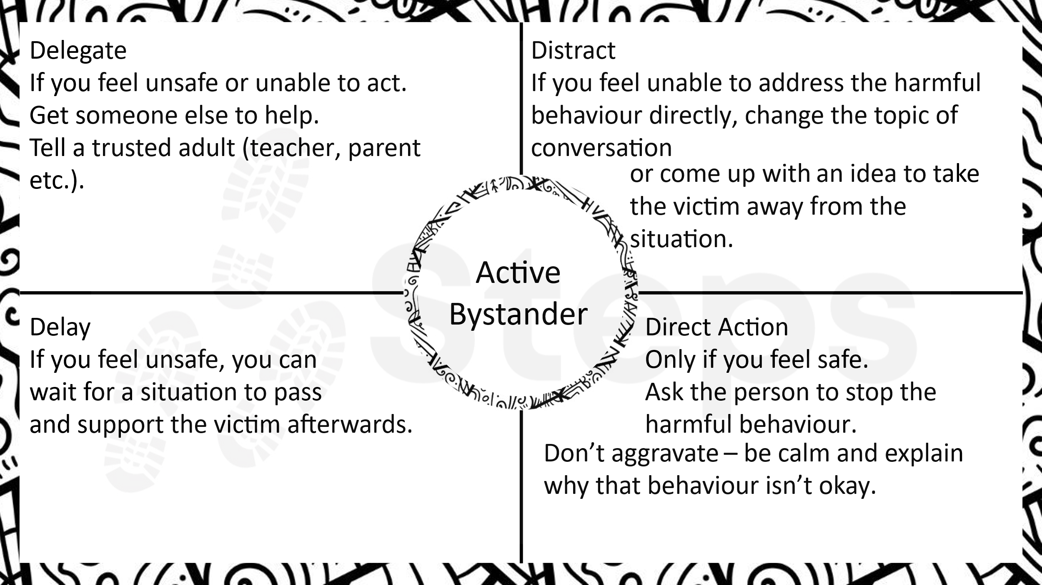
RESOURCE 6

Session Five

Learning objectives:
- To understand how we can take steps to regulate our emotions.
- To be able to articulate what they think a positive male culture is.

Facilitator guidance
Introduction
The facilitator highlights the importance of having a healthy online diet which they will be familiar with from the Universal sessions. The facilitator encourages the pupils to think about a time when they may have had a negative experience online. They don’t need to share this. Explain that when we feel attacked it can be hard to regulate our emotions. Explain that there is a way we can help regulate our mind by regulating our body. If the group are comfortable, take them through breathing techniques such as finger breathing and box breathing; also encourage them to be able to ‘shake it off’ to help ground their body and how to relax their body and focus on this rather than the emotions.

Phase One
The facilitator takes the group back through the sessions – what have we learnt? What are the needs of men and boys? How does society and its expectations have a negative impact on healthy ways of living (remind them of the work that was undertaken on hyper-masculinity).

The facilitator helps to record the pupils’ thoughts about what a positive male or boy culture could be. It may be helpful to encourage them to think of the negatives first and then think about the opposite of this. Encourage them to think about it in terms of behaviours/attributes/roles.

Phase Two
Repeat the exercise by looking at what a positive female culture would be. Again, look at the negatives and what burdens and expectations society puts on them before focusing on what it would look like and feel like if there was a positive female culture.

Go back to the definition of respect and share the resources from the Universal Sessions (Resource 8). Ask the pupils to think about what a positive culture would be in school if boys and girls were able to behave in a way that was one of mutual respect and consent. What would it look like? What would it feel like? How would it help them to feel better about themselves?

Ask the pupils to think about one thing they are going to commit to in order to bring about this positive culture. They write this individually and then give it to the facilitator. The facilitator should make a decision as to whether they are able to draw this together and share in a way that doesn’t undermine the moment. If there is a nervousness that it may make the pupils feel uncomfortable, don’t do it.

Phase Three
Ask the pupils if there is anything more that they feel they need to know about and give them an opportunity to share anonymously if they want to.

Finally, ask the pupils how being an active bystander at a young age can help make Violence against Women and Girls preventable, and not inevitable. Finish with positive recognition of their involvement in the project and their contributions.

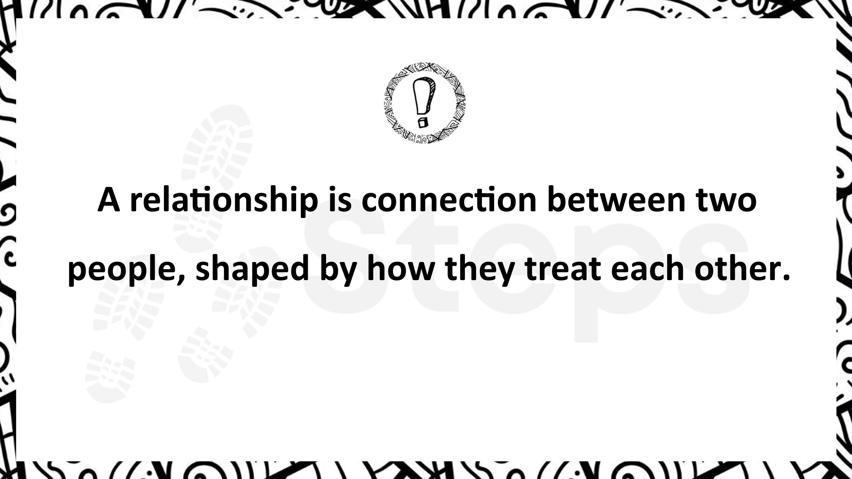
RESOURCE 8

